 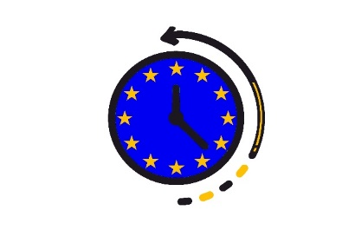

**EVENT INVITATION**

**Altius Foundation, Spain is pleased to invite to**

**INTERNATIONAL WORKSHOP “1948 – THE HAGUE CONGRESS AND THE INTEGRATION OF EUROPE”**

**To be held within the “European Union: common past, present and future to you” under the Europe for Citizens Programme – EU Remembrance.**

**The event will take place on March 13, 2020 (Friday) at Salesianos Estrecho school (C/Francos Rodriquez, 5, 28039 - Madrid from 10.00 to 14.30h.**

**Join us!**

**Let us discuss together our past in order to value our future!**

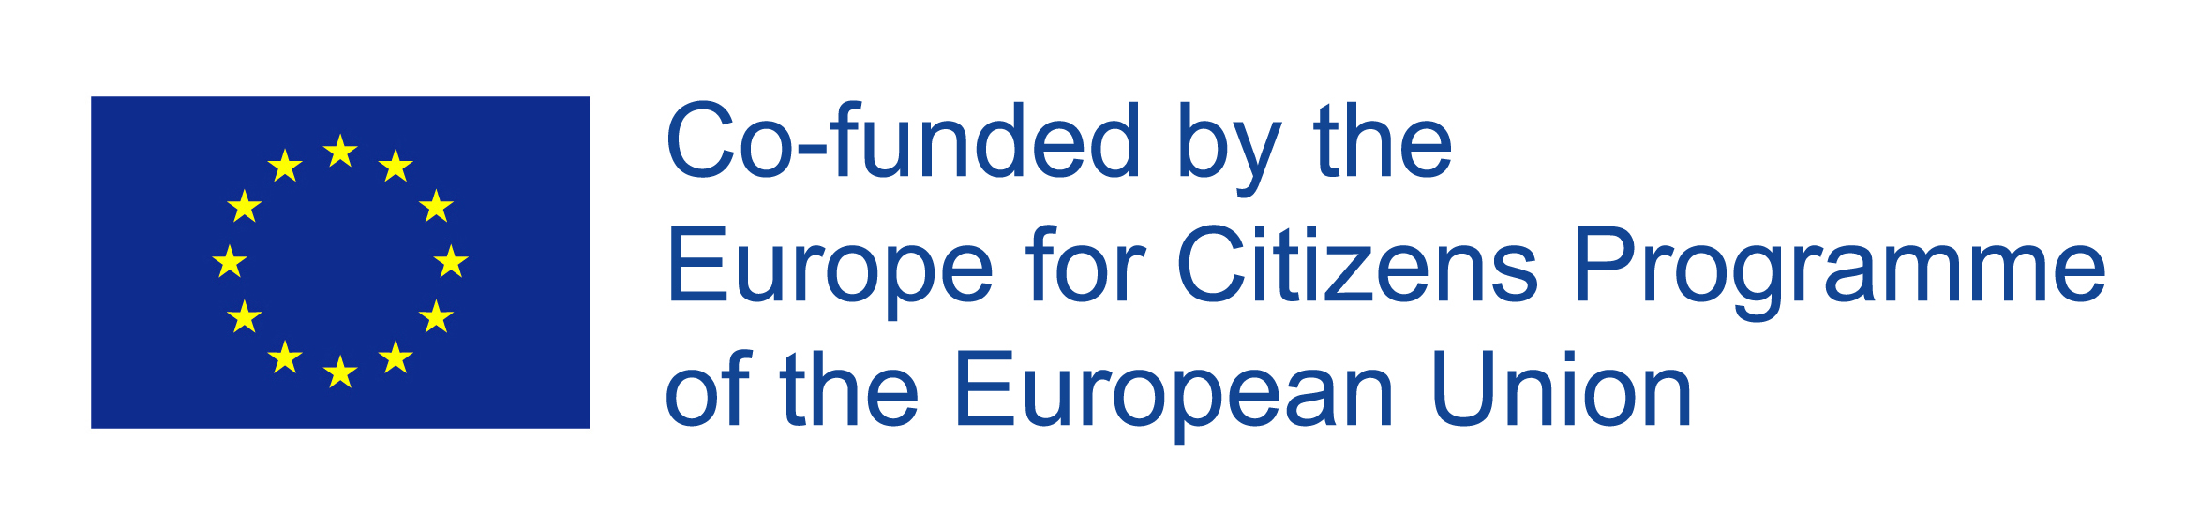

The project “EU: common past, present and future for you4U”is funded under the Grant Decision 2019-1293/001-001