 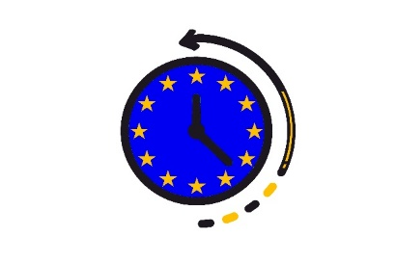

**Altius Foundation, Spain informs you that the**

**INTERNATIONAL WORKSHOP “1948 – THE HAGUE CONGRESS AND THE INTEGRATION OF EUROPE”**

**is cancelled due to the communication regarding CONVID-19 on behalf of the Regional Government of Madrid for the extraordinary measures in the field of education and complementary activities focus aimed at a wide audiences.**

**The Altius team**

**10 March 2020, Madrid**

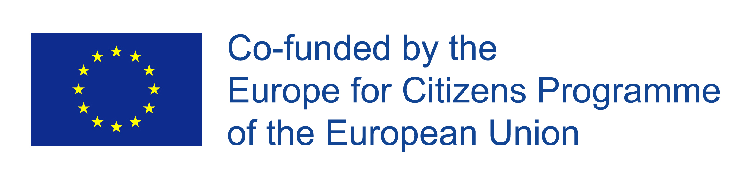

The project “EU: common past, present and future for you4U”is funded under the Grant Decision 2019-1293/001-001